Installing a Copier or Printer Via Papercut Knowledge Base Article

The following article will explain how to view the printers available to you and install/uninstall additional ones not forced installed onto your pc.

Click the Up arrow at the bottom right of the taskbar and right click the printer icon and choose view my printers

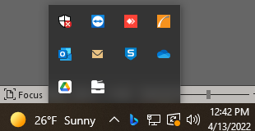

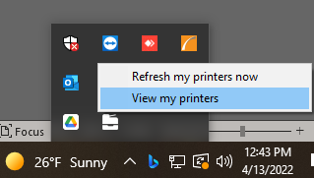

Papercut Client will load showing the My printers page and there you will see any printers that were forced installed or that you have installed through papercut on the pc. (Devices you manually install from under the Add printers tab should give you the option to click on the trash icon to remove them if you need.)

Note: Printers that the trash can icon is crossed out means it is a forced installed printer to your machine by the zone name next to the trash icon.

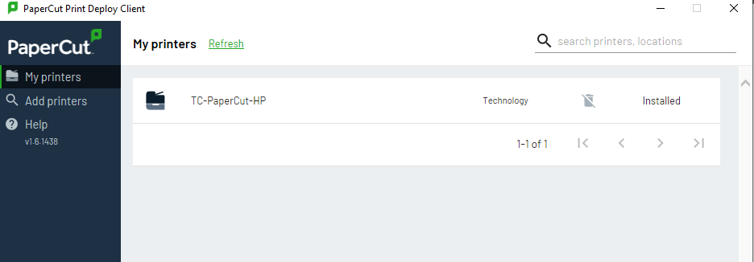

The Add printers page will list printers available to install. Simply click on Install next to the name of the printer you want to install, and you may have to enter your password and then the printer will disappear from the Add printer list and will show up in the My printers tab once it finishes installing.

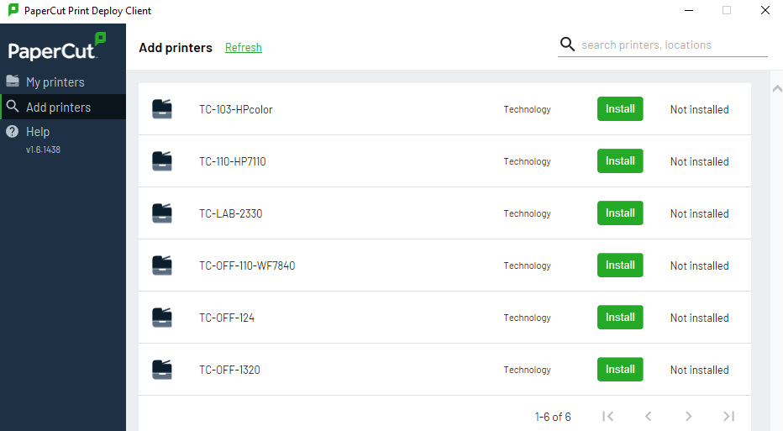

If you don't see a printer or copier, send in a work order and we can work to get it for you.

Article Made By: Nathan Egan

4-13-22

Ext. 9328

<https://d93.zendesk.com/hc/en-us/articles/5552884118932>