How to Display the Service Tag on a Chromebook Knowledge Base Article

Finding the Service Tag and OS Revision within Chrome OS

Locating the Dell Service Tag number or the Operating System (OS) revision for a Chrome system can be difficult for users not familiar with the Chrome Developer Mode (Dev Mode).

The instructions below show how to locate the Service Tag number and OS revision of a system, Out of the Box (OOB) or after Power Washing the system.

Locating the Service Tag

On a new system or one that was power washed, when you get to the Chrome Welcome screen, **press the ALT+V** hotkey combination and you will see a string of number in the upper right corner of the screen.

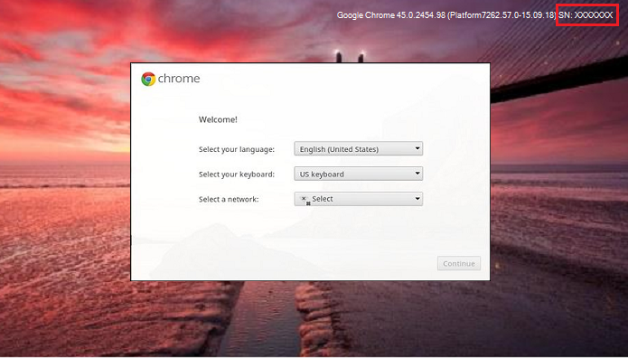

 The string begins with the Chrome OS version and ends with the Service Tag number. (Highlighted in red in the image above)

If you have further questions about this article, please contact the District Technology Department.

Affected Product

Chromebox, Chromebook, Chromebook 11, Chromebook 3100 2-in-1, Chromebook 3100, Chromebook 3120, Chromebook 11 3180, Chromebook 11 3189, Chromebook 5190 2-in-1, Chromebook 5190 Education, Chromebook 13 3380, Chromebook 7310, Chromebook 3400, Dell Chromebox 3010, ChromeBox For Meetings, Inspiron Chromebook 11 3181, Inspiron Chromebook 11 3181 2-in-1, Inspiron Chromebook 7486

Info in this article came from the Knowledge Base Article forms on dell’s website: <https://www.dell.com/support/kbdoc/en-us/000175440/how-to-find-the-service-tag-number-and-os-revision-on-chromebook-chromebox-within-the-operating-system>

Article Made By: Nathan Egan

9-14-21

Ext. 9328