Setting Up & Updating Classlink Password Recovery

When you sign in you will be prompted with this message, click on the Set Up Recovery:

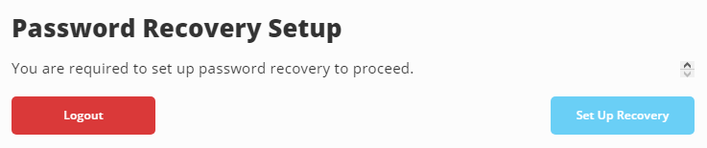

Configure whichever options you would like to use. (Mobile Phone, Email, Questions)

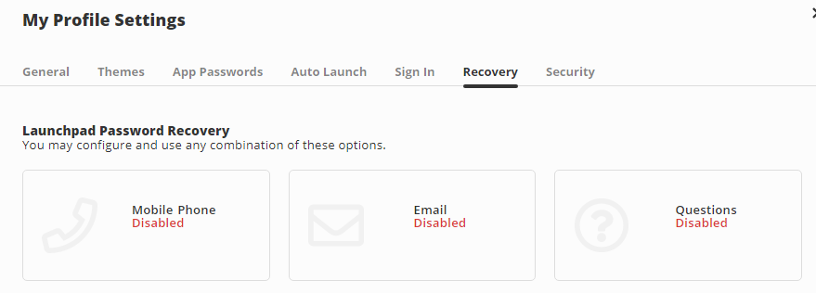

If you Choose Mobile Phone you will need to enter the full # with the area code, then select save and the site will send a text with a code to your phone. If you don't get it choose resend code. Enter the code and click submit and then your mobile option should be enabled.

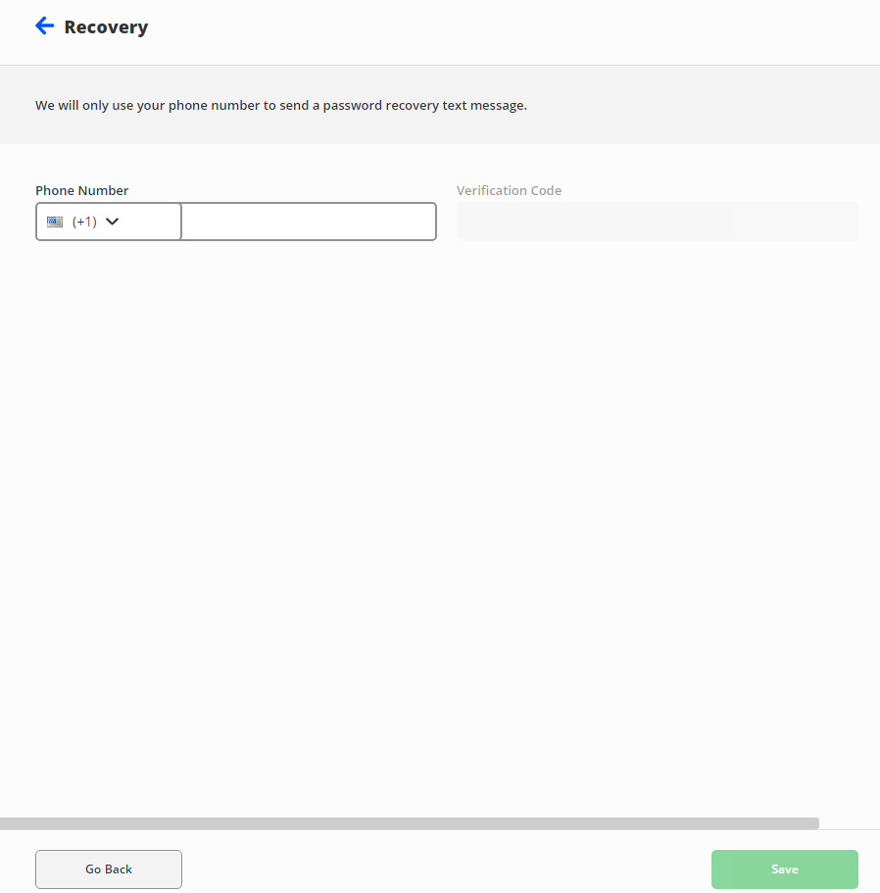

If you don't get it choose resend code. Enter the code and click submit and then your mobile option should be enabled.



If you choose the Email option, DO NOT USE YOUR DISTRICT E-MAILS FOR THE E-MAIL RECOVERY OPTION! If you are locked out, you won't be able to get to your @d93.k12.id.us or @d93mail.com emails to get the recovery email. Enter your email and then choose save and it will email you, open the e-mail and finish verifying and the e-mail option should be enabled for you.

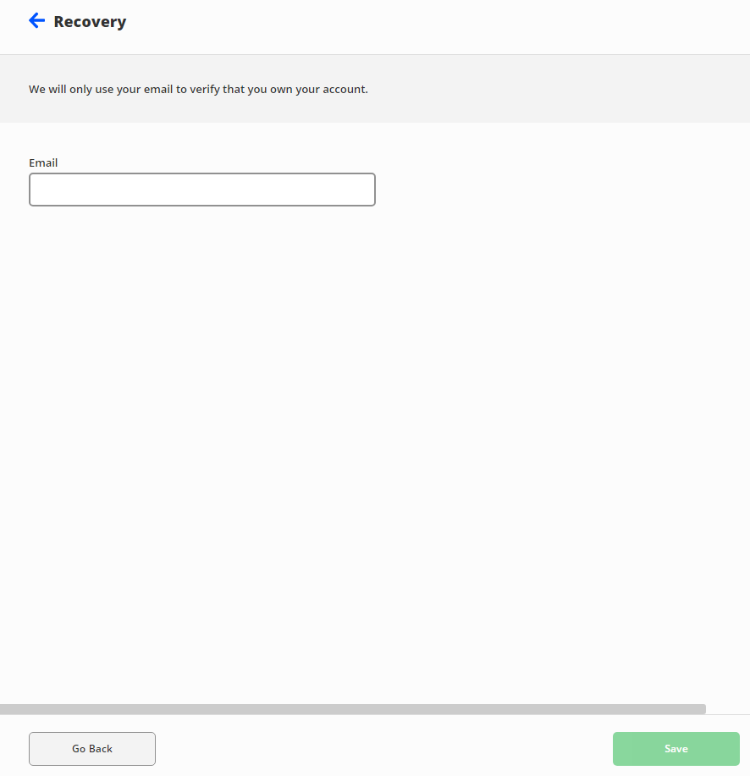

If you Choose Questions you can either choose from a list of questions, or you can choose custom and create your own questions. We encourage you to use questions and answers that are not easy for others to guess. Hit save at the bottom right when you are done & then the recovery question option should be enabled for you.

You may want to consider saving the questions and answers you choose and keeping them in a secure place.

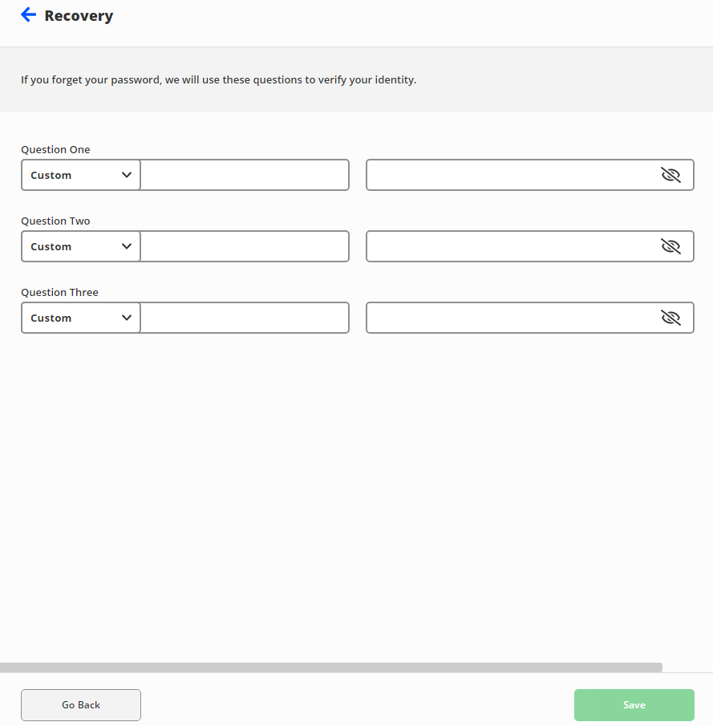

If you get a new phone # or change emails, you sign into Classlink and then click the arrow in the top right and choose SETTINGS, then click on Recovery and then you can click on the option you want to update or remove. This is also where you can choose to reset your password by clicking on the Reset Password Button.

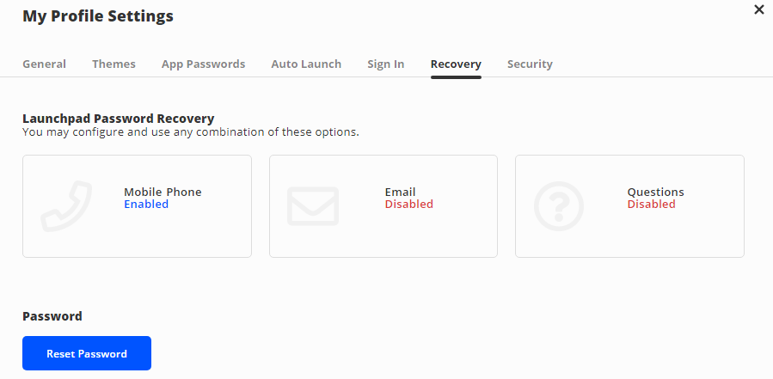

For an example if you want to update the mobile phone #, click on it and then click on Delete above the number, then enter your new number, hit save and then when you get the code enter it and click submit and then your recover number should be updated.

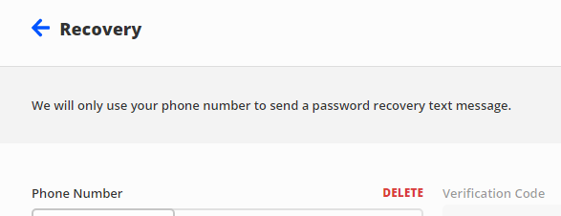

You always have to have at least 1 recovery option set up & you can set up all 3 recovery options, but we recommend you set up at least 2 so for example if you change your phone number you could still recover your account and then get in and update that recovery option. With that being said, please remember to come into Classlink and update your recovery options if your phone number or email changes, or if any of your answers to your security questions gets compromised.

There are additional Classlink articles here on the District Helpdesk you can refer to and you may reach out to the D93 Technology Department if you have any other questions.

Article Made By: Nathan Egan

6-24-21

Ext. 9328

<https://d93.zendesk.com/hc/en-us/articles/4402670233492>