Setting Up Classlink Multi-Factor Authentication for Staff
Log In
If it is enforced for you to set it up you will see is screen:
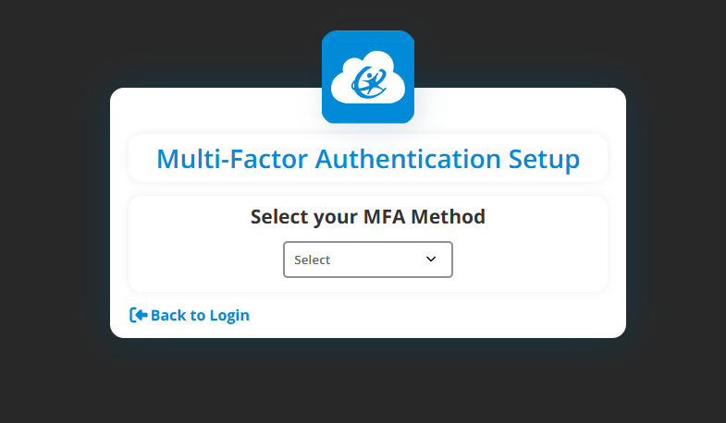
If not enforced & you don’t see the screen above you can sign into Classlink, click on the box in the top right, then select settings. Then click on the Security Tab & there should be an option to set up your Multi-Factor Authentication. (If you already have it set up & are trying to change MFA settings, you can go to the same spot referenced above to get to the settings.)

Choose your Preference from the list in the dropdown:
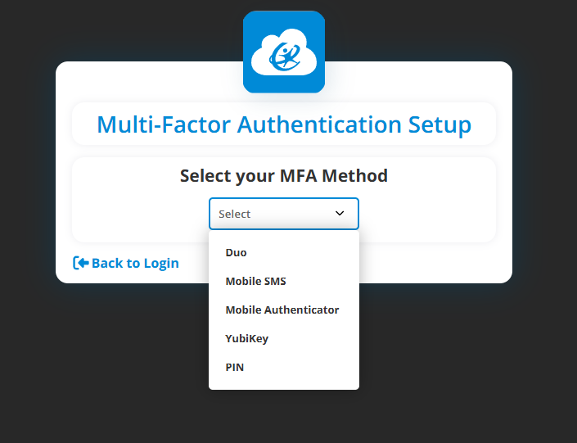

Below are the different options you can go through, but the 2 we recommend are either a Mobile SMS or Mobile Authenticator:

Mobile Option (Recommended)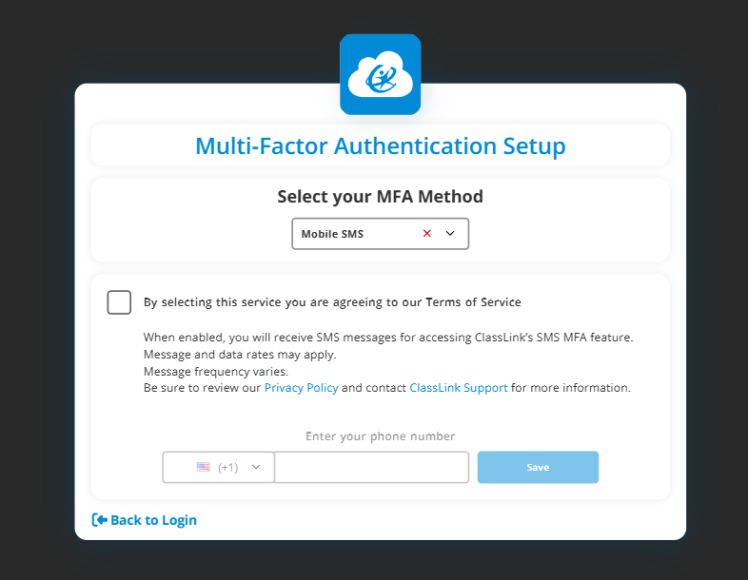

Mobile Authenticator Option (Recommended)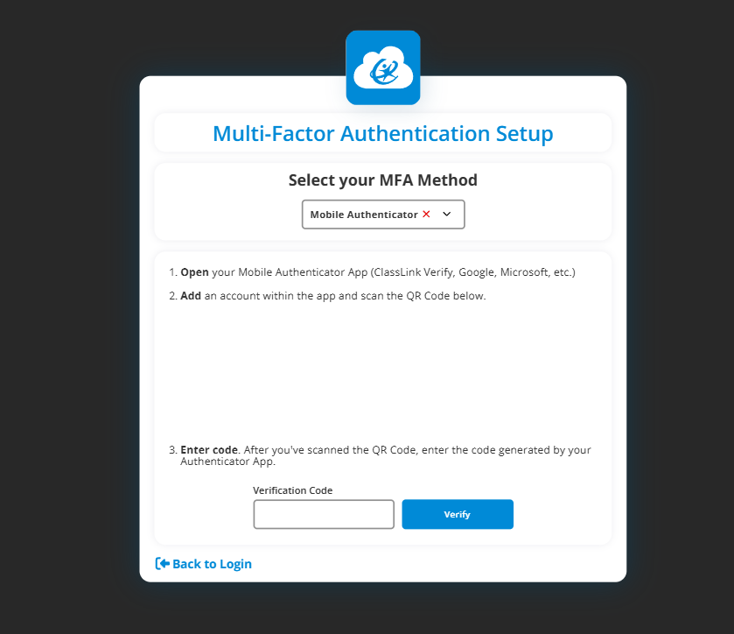

Pin Option: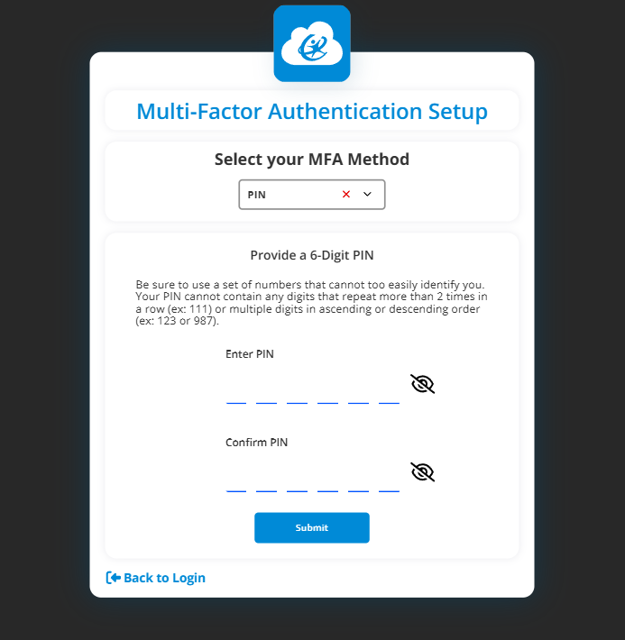

Duo Option (This option will let you do a prompt to approve so you don't have to enter a code but you will need to contact Technology to get registered in Duo.)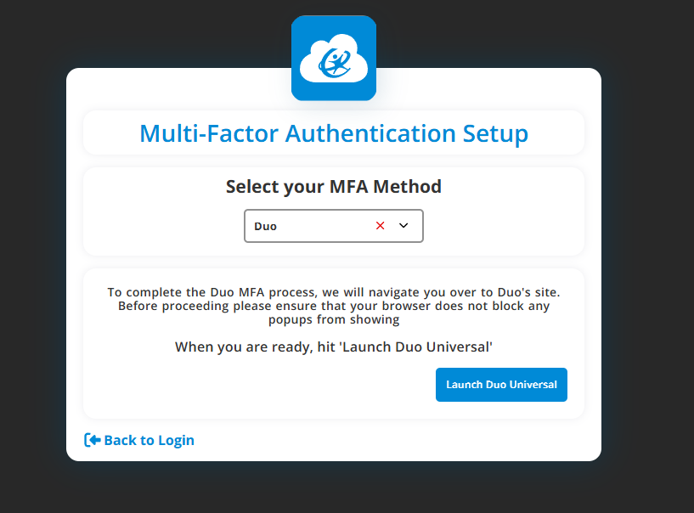
Set up by sending code to your app.
It will provide the code to put into the app.

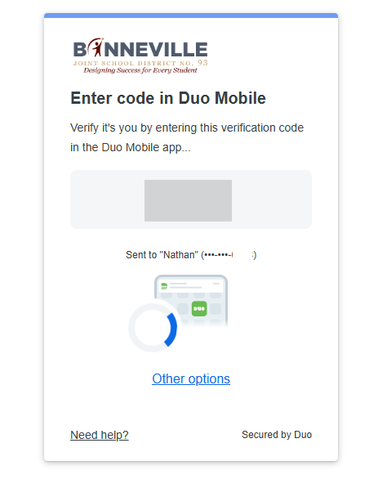

You will see that it has succeeded.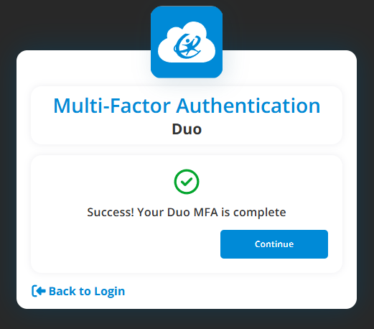

YubiKey Option: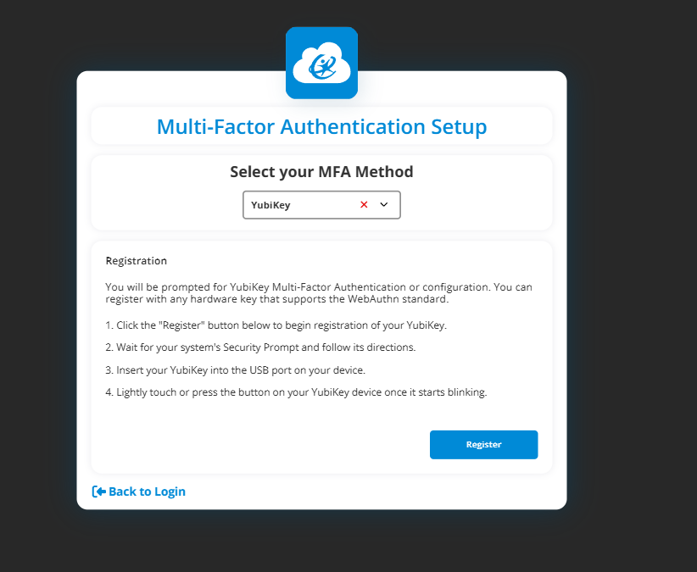

If you have any problems with setting up MFA for Classlink you can send in a work order in the D93 Zendesk or contact the Technology Department at 208-525-4493

