How to Report Phishing Emails with CyberNut

How to Report Phishing Emails With CyberNut

If you suspect an email to be a Phishing email, navigate to the Cybernut Taskpane to report it.

From Program Outlook on Devices it will be on the Outlook Ribbon on top.

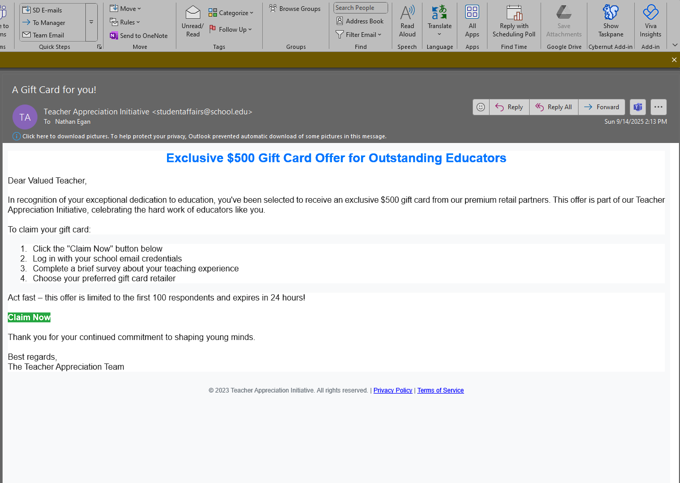

On Web Outlook it will be a smaller icon near the forward button. (See circled Blue Squirrel icon in image below.)

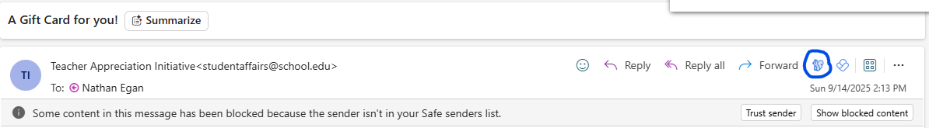

The Panel will open up & then you can click on the red Report Email button.

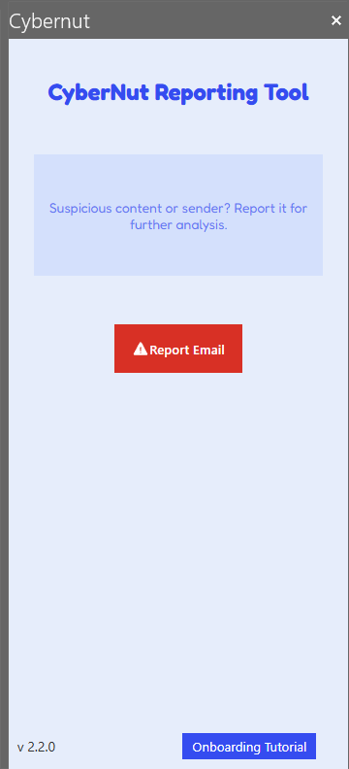

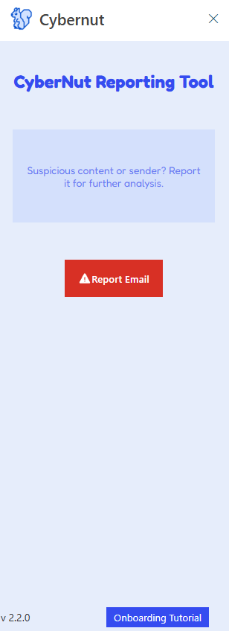



If the email was created by Cybernut you will see a window open up that you caught their training/test one that they send out periodically. If it was not sent by them it will still open a window and let you know the email is being sent to a team to investigate it.

If you have any other questions about Cybernut or emails you can contact the technology center @

208-525-4493

Article Created by Nathan Egan

9-16-25