Moving Data from One Google Account to Another Knowledge Base Article

KB:00176

First go sign into the Google Account that has the Google Drive & or Gmail you want to move and click on the circle at the top right & then click on Manage your Google Account.

On your account page Google has a Transfer Your Content Wizard that you click Start transfer.

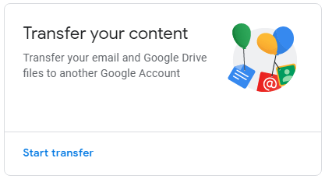

You will enter the e-mail to the account you wish to transfer the files to.

Important Note, the account you are transferring to needs to have enough space to work. You can check the storage size back on the account page and their will be a section titled Account storage that will show the total space used for your entire account. You can click on manage Storage and it will show you how much storage your using between Google Drive, Gmail, Google Photos and possibly other Google App Platforms. (You can do this for both accounts to see the amount of space to transfer & the amount of room available to transfer to.) I recommend you clear the recycle bins of both Google Drive Accounts before looking at these amounts.

Another Important Note: As of May 2019 Google says this is only available to do from School Accounts to other accounts.

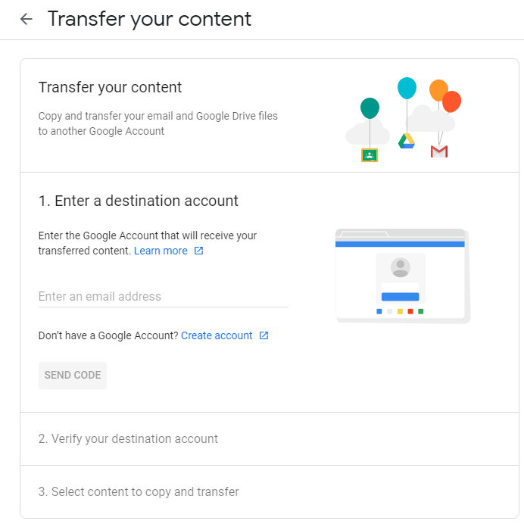

It should send a verification code to the account e-mail you want to receive the files.

Once you enter the code into the wizard, you can choose what you want to move, like if you don’t want the e-mail to transfer, you can slide it off and it will only move the Drive folder.

It will e-mail you when it has completed transferring but it could take a couple of days.

Google says: Copied content will be in a folder labeled with your school account name and the date you started the copy process.

If they are not in your main drive, check the Team Drive section.

Article to reference: <https://support.google.com/accounts/answer/6386856?visit_id=636942278371147552-932711904&p=transfer_content_emailstep&hl=en&rd=1>

Knowledge Base Article Made by Nathan Egan 5-23-19 Updated 10-26-20

[egann@d93.k12.id.us](mailto:egann@d93.k12.id.us)

Ext. 9328

User URL: <https://k1000.d93.k12.id.us/userui/advisory_detail?ID=176>

Admin URL: <https://k1000.d93.k12.id.us/adminui/advisory?ID=176>