Backup & Sync Test Instructions
Here is a step-by step of how to test that your Google Backup & Sync to make sure it is configured properly & is backing your files up to Google Drive.

Testing to Make Sure Backup & Sync Is Configured Correctly

Step 1: Open a Document in Word
Type Backup & Sync Test Spring [Enter Current Year]

Step 2: Save it to Your Desktop Named Backup & Sync Test Spring [Enter Current Year]
(For this demonstration I am going to save this document as Backup & Sync Test Instructions.)
Step 2a: If you would like, Click on the bottom right single grey cloud icon and verify that the file is there.
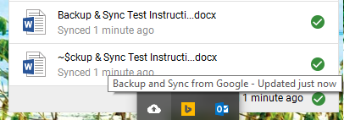
Step 3: Navigate to Google Drive by either typing in drive.google.com or on google click on  in the top corner and click 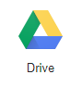

Step 4: Sign in with your district username@d93mail.com & password.
Once signed in you should have a folder called  Double Click on it & in that folder you should have a file named Backup & Sync Test Spring 2018.
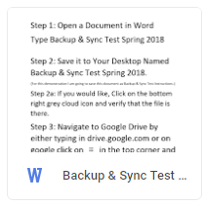
If it is there you are set right and things are likely working right. If you don’t see the file or don’t even have a Desktop folder, you can either panic or contact your Building Tech
(While you are on your main google drive page, you may want to check that you also have a Documents, Pictures, & Favorites Folders that should be backing up there as well.)
Don’t forget to also Backup your files to a Jump Drive or External Hard Drive.
Side Note Reminder, you may have to sign back into backup & sync when returning from Summer Break to restore your files from the cloud onto your pc.
(The Technology Department & building techs are not responsible for lost or misplaced files.)

Article Made By:
Nathan Egan
Ext. 9328
5-4-20

