Adding Guardians to Students in Google Classroom

Go to a classroom the student is in and go to the people page.

If you have not added a guardian yet click where it says Invite Guardians.

If you have already added one parent and want to add another one, click the Hotdogs (3 dots) next to the student and select add guardian.

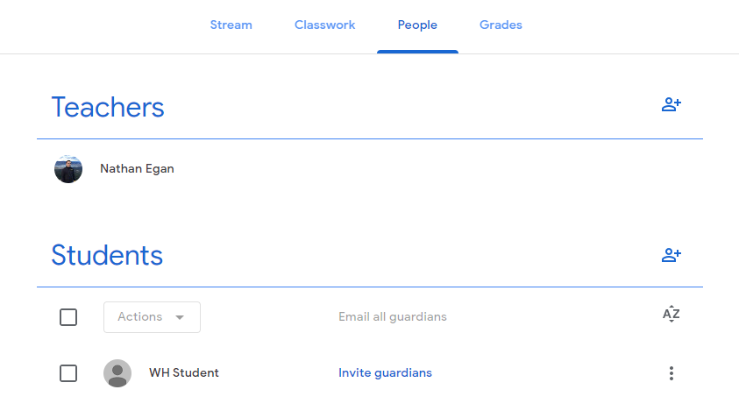

Once you have added the guardian’s e-mails select invite.

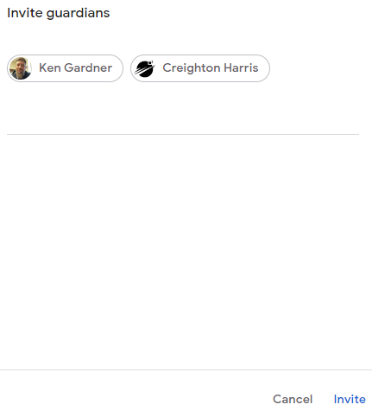

They will get an e-mail to accept the invitation to be the student’s guardian.

Example of options you have once you have a guardian added when you click the hotdogs by the student name.

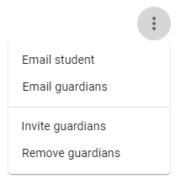

It is where you can Invite additional guardians and have the option to email the student or the guardians. You also have the option to remove guardians and you can choose the one you want to remove, and you will get a verification question of the parent you wish to remove. Select remove and they will no longer be a guardian of that student for any Google Classroom they are enrolled in.

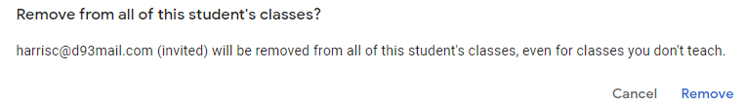

Additional info regarding Guardians and an example of what the e-mail summaries from a teacher may look like can found at:

<https://support.google.com/edu/classroom/answer/6388136?hl=en>

Article Made By:

Nathan Egan

4-10-20