Creating Google Meet in Google Classroom

You may see this popup when you go into your classroom that can help provide info about Google Meet in the classroom. If you don’t see it, or already closed it, you can still set up Meet in your Classroom.



The way to set it up is to go to your classes page. (You will have to do this for each Google classroom that you want to have its own Google Meet. You also can still set up Meets in Google Calendar the original way.)

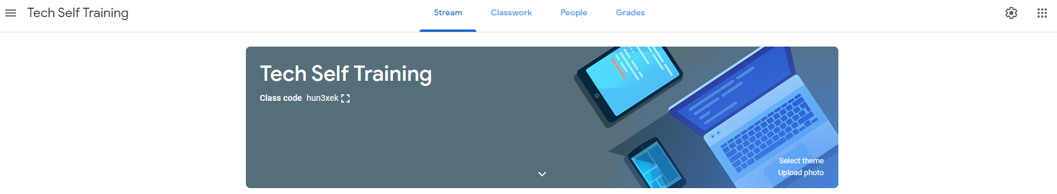

Click on the gear in the top right.

Scroll to the general section and at the bottom of general is where you can click on Generate Meet link.

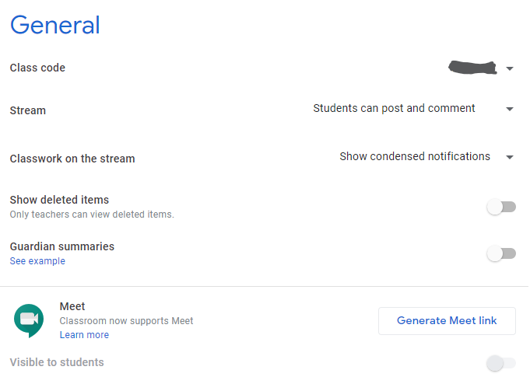It will then look like this

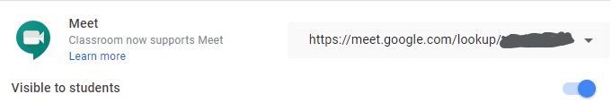

(The part I have grayed out is going to be your classes Meet code that you can give to students.)

**Hit save button at the top right of the class settings screen when you are done.**

Here you can also click the drop-down arrow and copy the link, or you also have the option to choose to reset which will disable the old link and create a new one for you.

(If you ever have someone join the class that you do not know who they are, we suggest that you reset the meet link so it will hopefully stop them from joining in the future.)

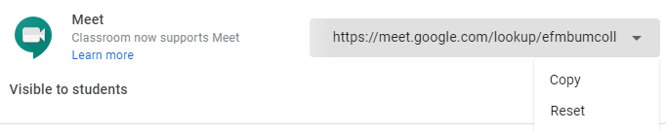

So now you have the option to either post on the steam page in an assignment or a regular post the link to the meet telling the kids to join at a certain time or you can just tell them to go to the Classwork tab and click on the meet button. (Note that the meet button only shows up under the classwork tab if you have the Visible to Students setting on in the class settings mentioned earlier.)

Stream Post Example

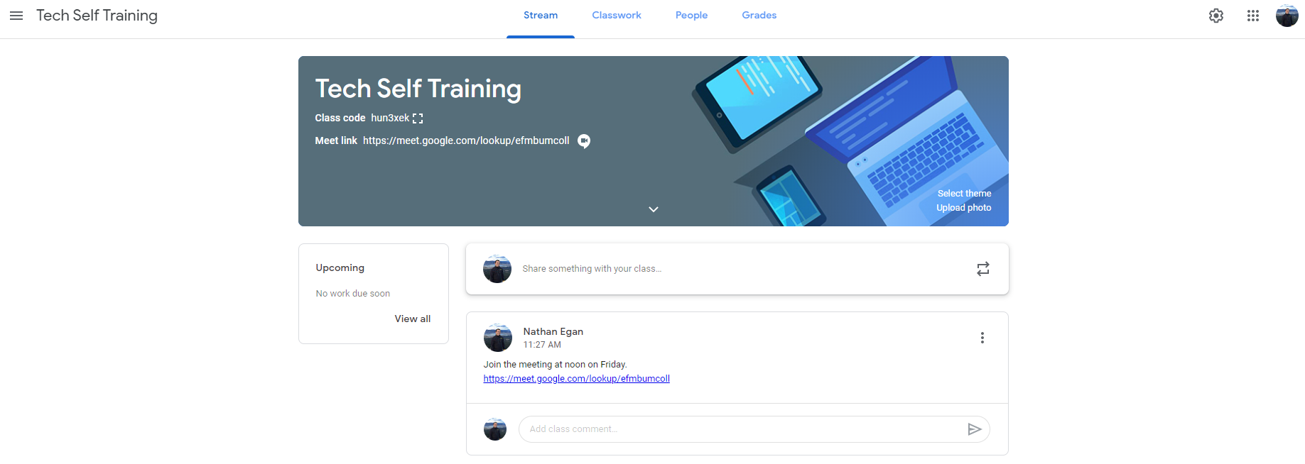

Meet Button on Classwork Page Example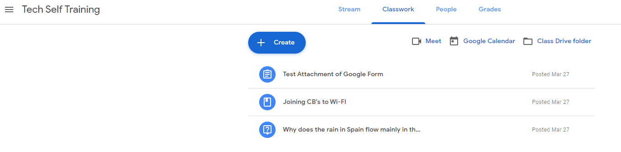

When the Google Meet is setup in your classroom only the students and the teachers in the class should be able to join it. If you get outside account requests, be careful, they could be a person with bad intentions. Reminder that teachers are the host of the meeting and also have the ability to mute and or remove users from the meeting.

Additional step-by-steps for how the students can join a Google Meet can be found here:  
<https://support.google.com/edu/classroom/answer/9777280>

Additional info about Google Meet in Google Classroom can be found by going here: <https://support.google.com/edu/classroom/answer/9776888>

Article Made by:

Nathan Egan

4-10-20

